SECTION A: WEBSITE PLANNING & DOCUMENTATION
1. Website Specifications
a. Website Objective & Goals
The website to be developed is for a gaming equipment company called Luxinations. The company specializes in the sale of a wide range of gaming products including gaming PCs, consoles, accessories, and peripherals.
The main objective of the website is to:
- Provide an online platform for showcasing and selling gaming equipment
- Deliver detailed and accurate product information to customers
- Create an engaging and visually appealing experience for gamers
The goals of the website include:
- Increasing product visibility and online sales
- Building a strong brand presence in the gaming market
- Providing a smooth and user-friendly browsing experience
- Encouraging customer interaction through feedback and contact features
b. Target Audience
- Age: 15 – 40 years
- Gender: All genders
- Location: Botswana and international online users
- Occupation: Students, gamers, streamers, IT enthusiasts
Technical Aptitude:
- Moderate to high computer literacy
- Familiar with gaming platforms and online shopping
- Comfortable navigating modern websites and digital interfaces

c. Type of Website
The website is an E-commerce gaming website.
It will include:
- Product catalog (gaming PCs, consoles, accessories)
- Informational pages (About, Contact)
- A feedback page with a form
- Promotional banners and featured products

Navigation Structure
- The Home page serves as the main entry point
- A navigation bar will appear on all pages
- Users can easily move between pages in 3 clicks or less
- Dropdown menus will be used under “Products” for categories
Content Organization
- Products are grouped into logical categories:
  - Gaming PCs
  - Consoles
  - Accessories
  - Peripherals
- Each category will display related items with images and descriptions
- Important information such as contact details and feedback forms are placed in separate dedicated pages

SITE MAP
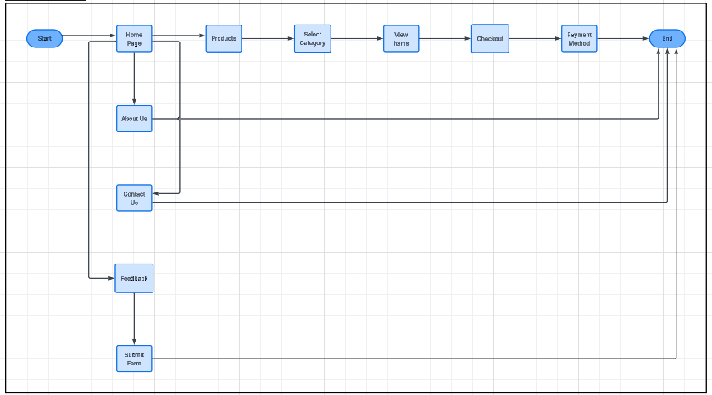

A cart will be included to the website for use of user storage of desired items. All payment methods will be accepted from bank cards to cryptocurrency.
3. Technical Brief
Technologies Used
- HTML5
Used to structure the content of the website (pages, headings, forms, etc.)
- CSS3
Used to style the website (colors, layout, fonts, responsiveness)
- JavaScript
Used for interactivity such as form validation and dynamic elements
- Bootstrap Framework
Used to create a responsive design that works on different screen sizes
Software Tools
- Visual Studio Code (VS Code)
Used for writing and editing code
- GitHub
Used for version control and storing the website files
- GitHub Pages
Used for hosting and publishing the website online

Graphics & Design Tools
- Canva / GIMP
Used for creating:
  - Logos
  - Banners
  - Product images
  - Website graphics

Testing Tools
- Web browsers such as:
  - Google Chrome
  - Mozilla Firefox
  - Microsoft Edge
These will be used to test compatibility and performance of the website.

WIRE FRAME
